# **Task 1**

Step 1: Use the text of the Gettysburg Address as the original article file gettysburg.txt. The usage of tr is available in GNU documentations. -d means 'delete' and -cd means 'delete the complement of', so first we just keep the letters, spaces, and newlines as the plaintext.



Step 2: Use Python console to generate a permutation of a-z:

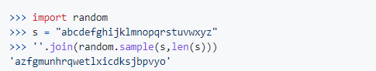

Step 3: Encryption



## Break

Use http://www.richkni.co.uk/php/crypta/freq.php to analyze the frequency of ciphertext.txt, its full report shows as analysis.md.

By single letter frequcey,the letters in ciphertext sorted by frequency are:

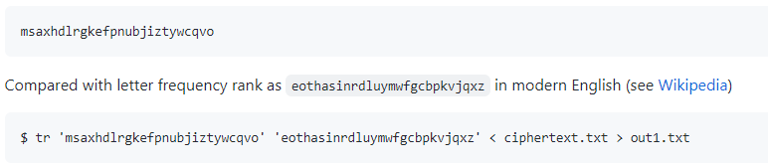

# Task 2

Ref to the manual of enc.

## **Cipher Block Chaining (CBC)**

Each block of plaintext is XORed with the previous cipher block.

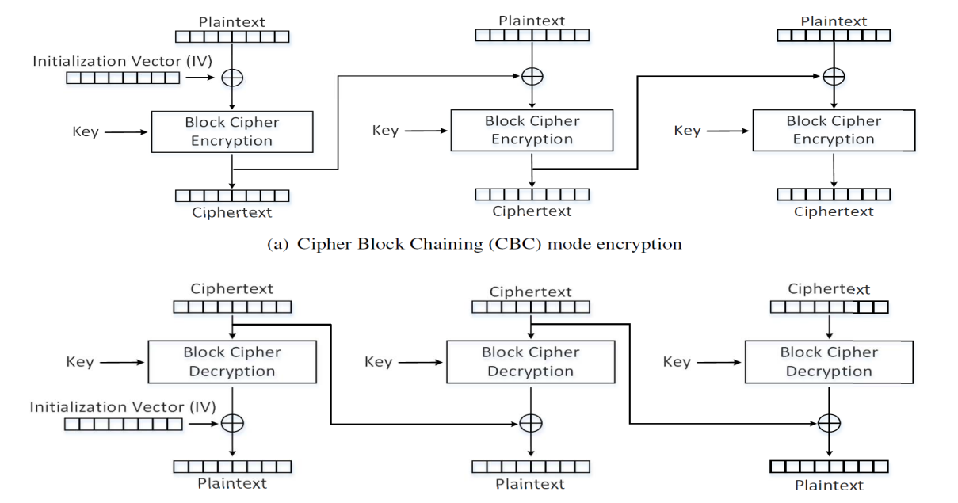

## 

## **Cipher Feedback (CFB)**

The ciphertext from the previous block is fed into the block cipher for encryption, and the output of the encryption is XORed with the plaintext to generate the actual ciphertext.

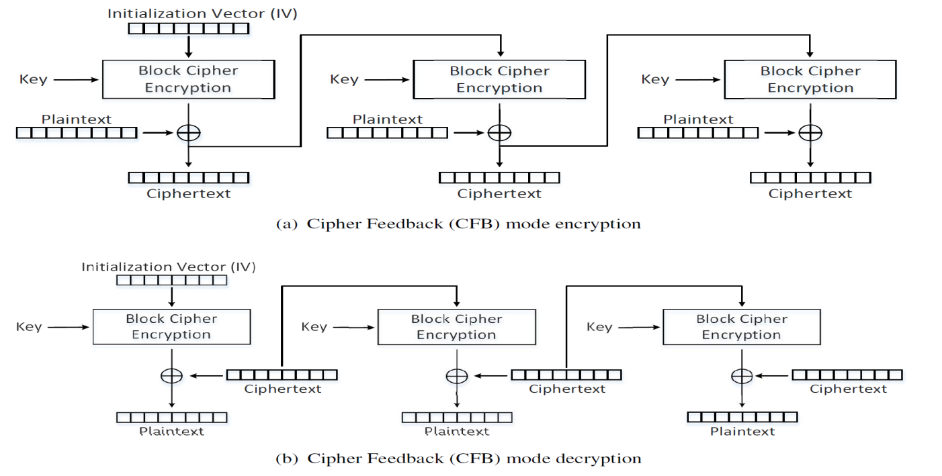

## 

## **Output Feedback (OFB)**

Similar to CFB, except that the data **before** (while in CFB, it should be "after") the XOR operation is fed into the next block.

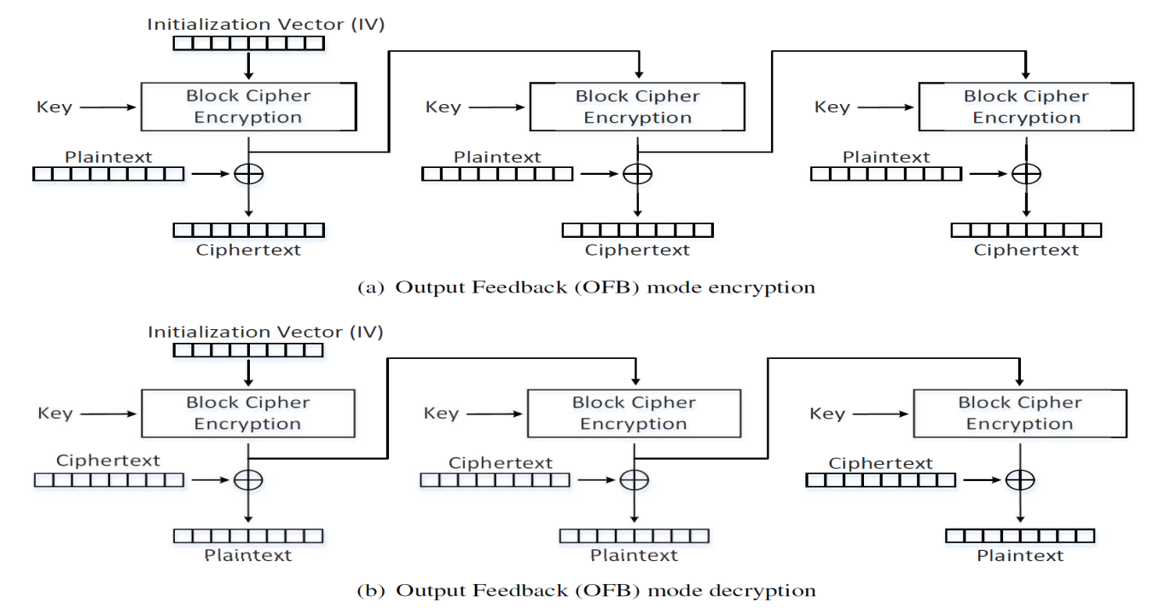

## 

## **Counter (CTR)**

Each block of key stream is generated by encrypting the counter value for the block. Nonce servers as IV, increased by some value (no need to be fixed to 1 ) as a counter.

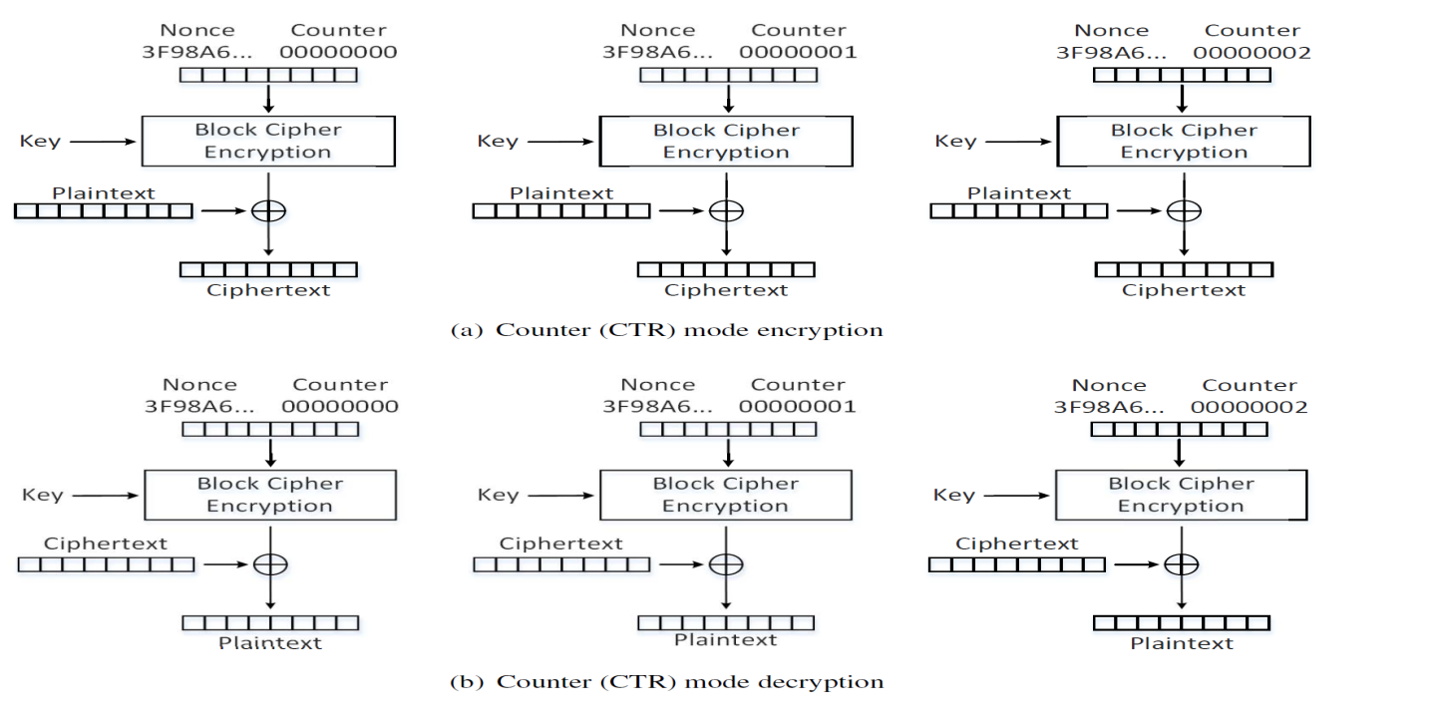

# 

# **Task 3**

Encrypt the picture pic_original.bmp as





Reset the header of the encrypted picture to make it openable by picture viewer:

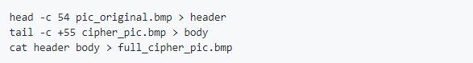



It seems similar to the original picture in some way. Because we break the file into blocks of size 128 bits, and the use AES algorithm to encrypt each block. If two blocks are the same in the original picture, they will remain identical in the encrypted one.

# **Task 4**

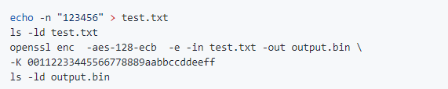

It shows that test.txt has 6 bytes while output.bin has 16. Padding occurs during ECB encryption.

Similar, try other modes by replacing -aes-128-ecb and adding the argument -iv

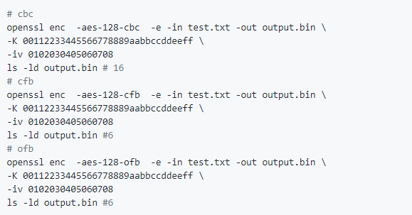

CFB and OFB don't need padding. Because they take outputs of the previous block, which must be of the same size equal to cipher block size, as the inputs of its last cipher block encryption.

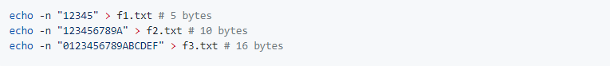

Encrypt 3 files with CBC mode:

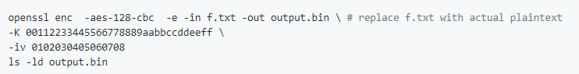

It shows that the output of **f3.txt** contains 32 bytes but the other 2 has 16 bytes.

The original **f1.txt**:



Decrypt **output.bin** with **-nopad**:

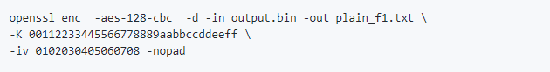

Then the output file has 16 bytes, and:



The paddings during encryption are treated as ciphertext.

# **Task 5**

Create a big file containing more than 1000 bytes

$python -c "print '1234567890'*100" > big_file.txt

$-ld big_file.txt

#1001

Encrypt it and then decrypt:

openssl enc -aes-128-ecb -e -in big_file.txt -out output.bin \

-K 00112233445566778889aabbccddeeff

Or

openssl enc -aes-128-cbc -e -in big_file.txt -out output.bin \ #replace cbc as cfb,ofb

-K 00112233445566778889aabbccddeeff \

-iv 0102030405060708

corrupt the 55-th(0x37) byte of output.bin as 0x00 using bless

And then decrypt it:

openssl enc -aes-128-ecb -d -in output.bin -out decrypted.txt \

-K 00112233445566778889aabbccddeeff

Or

openssl enc -aes-128-cbc -d -in output.bin -out decrypted.txt \ #replace cbc as cfb,ofb

-K 00112233445566778889aabbccddeeff \

-iv 0102030405060708

Check their differences by [diff.py](https://github.com/li-xin-yi/seedlab/blob/master/Secret-Key-Encryption/diff.py):

#!/usr/bin/python3

with open('big_file.txt', 'rb') as f:

f1 = f.read()

with open('decrypted.txt', 'rb') as f:

f2 = f.read()

res = 0

for i in range(min(len(f1), len(f2))):

if f1[i] != f2[i]:

res += 1

print("diff bytes: "+str(res+abs(len(f1)-len(f2))))

diff between the original files and decrypted files:

|  |  |
| --- | --- |
|  |  |
|  |  |
|  |  |
|  |  |

# Task 6

## Task 6.1

When plaintexts are the same, using the same IV leads to the same ciphertexts.

## Task 6.2

For OFB mode, If the **key** and **IV** keep unchanged, known-plaintext attack is feasible.

Output stream can be obtained by XORing plaintext and ciphertext block by block. Similarly, to get plaintext, I can XOR plaintext and ciphertext. When sharing the same key and IV for OFB mode, the output streams are **identical** among encryptions.

[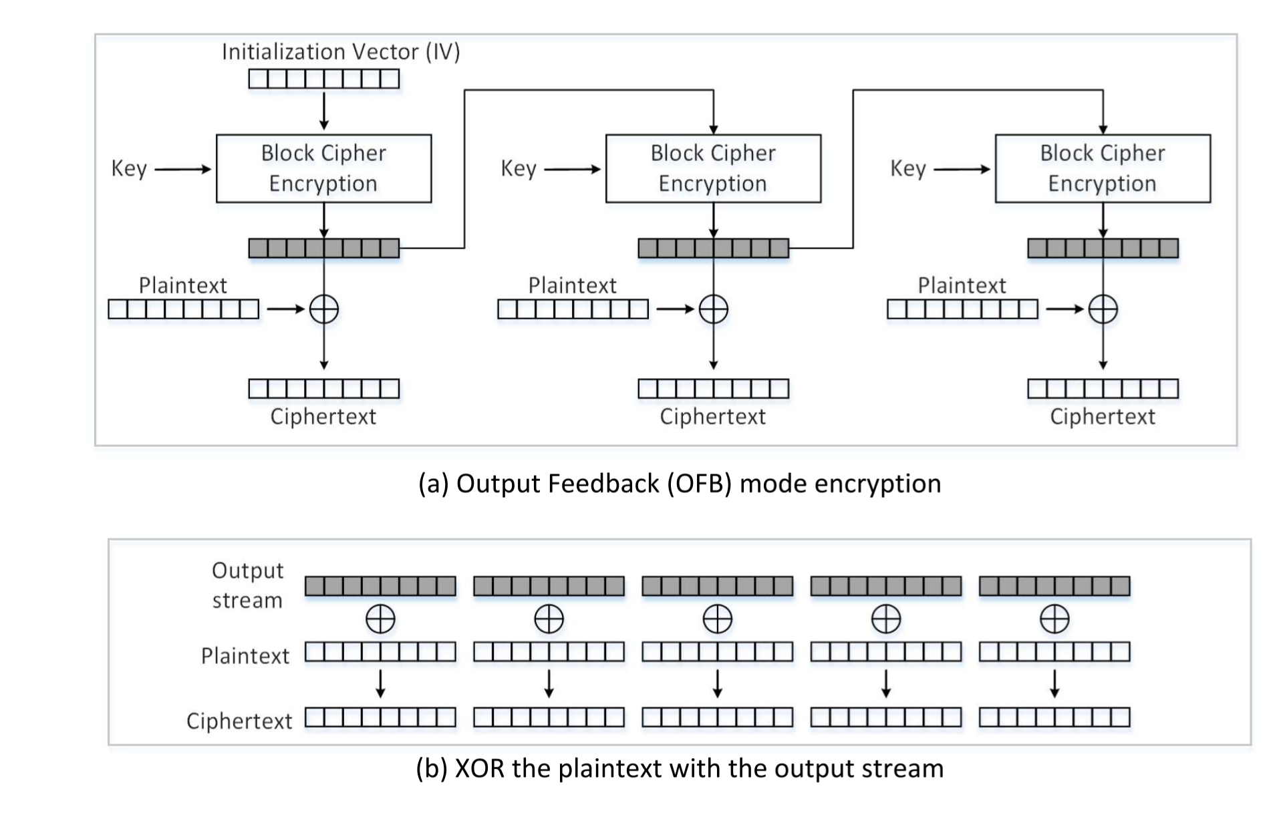](https://github.com/li-xin-yi/seedlab/blob/master/Secret-Key-Encryption/reuse_iv.png)

Assuming that we know a plaintext p1 and its OFB ciphertext c1, and another OFB ciphertext c2 with the same key and IV. But we do not know the plaintext p2 of c2, to figure about it:

First, get the output stream from the encryption of the first plaintext p1:

output_stream = p1 XOR c1

Then get p2 by:

p2 = output_stream XOR c2

Reduce it to:

p2 = p1 XOR c1 XOR c2

Use [known-plaintext-attack.py](https://github.com/li-xin-yi/seedlab/blob/master/Secret-Key-Encryption/known-plaintext-attack.py):

#!/usr/bin/python3

from sys import argv

_, first, second, third = argv

p1 = bytearray(first,encoding='utf-8')

c1 = bytearray.fromhex(second)

c2 = bytearray.fromhex(third)

p2 = bytearray(x ^ y ^ z for x, y, z in zip(p1, c1, c2))

print(p2.decode('utf-8'))

On the instance of

Plaintext (P1): This is a known message!

Ciphertext (C1): a469b1c502c1cab966965e50425438e1bb1b5f9037a4c159

Plaintext (P2): (unknown to you)

Ciphertext (C2): bf73bcd3509299d566c35b5d450337e1bb175f903fafc159

known-plaintext-attack.py "This is a known message!" \

a469b1c502c1cab966965e50425438e1bb1b5f9037a4c159 \

bf73bcd3509299d566c35b5d450337e1bb175f903fafc159 \

Get P2 as "Order: Launch a missile!"

For CFB mode, as [its demonstration](https://github.com/li-xin-yi/seedlab/blob/master/Secret-Key-Encryption/README.MD#cipher-feedback-cfb), it is the same situation for the initial block (i.e. can get plaintext by simple XOR). However, if the key remains secret, the following parts of ciphertext will not be revealed.

## Task 6.3

I guess p1 is "Yes".

So construct

P2 = "Yes" XOR IV XOR IV_NEXT

Where IV is the IV used to generate C1 and IV_NEXT is the predictable IV used to encrypt the next plaintext input.

In this case:

Encryption method: 128-bit AES with CBC mode.

Key (in hex): 00112233445566778899aabbccddeeff (known only to Bob)

Ciphertext (C1): bef65565572ccee2a9f9553154ed9498 (known to both)

IV used on P1 (known to both)

(in ascii): 1234567890123456

(in hex) : 31323334353637383930313233343536

Next IV (known to both)

(in ascii): 1234567890123457

(in hex) : 31323334353637383930313233343537

In practice, because the length of the payload is too short, which is required to padding according to [PKCS#7](https://tools.ietf.org/html/rfc2315#section-10.3), We have to do some subtle adoption based on [known-plaintext-attack.py](https://github.com/li-xin-yi/seedlab/blob/master/Secret-Key-Encryption/known-plaintext-attack.py) to create [cipher_cons.py](https://github.com/li-xin-yi/seedlab/blob/master/Secret-Key-Encryption/cipher_cons.py):

#!/usr/bin/python3

from sys import argv

_, first, second, third = argv

p1 = bytearray(first, encoding='utf-8')

padding = 16 - len(p1) % 16 # padding to match the block size as 128 bit

p1.extend([padding]*padding)

IV = bytearray.fromhex(second)

IV_NEXT = bytearray.fromhex(third)

p2 = bytearray(x ^ y ^ z for x, y, z in zip(p1, IV, IV_NEXT))

print(p2.decode('utf-8'), end='')

cipher_cons.py "Yes" 31323334353637383930313233343536 31323334353637383930313233343537 > p2

To get c2, query with p2:

openssl enc -aes-128-cbc -e -in p2 -out c2 \

-K 00112233445566778899aabbccddeeff \

-iv 31323334353637383930313233343537

Note that when the plaintext is a multiple of 16 bytes, it should be padded with another 16 bytes according to [PKCS#7](https://tools.ietf.org/html/rfc2315#section-10.3) for encryption. To compare with actual c1, we just need the first block of c2:

$xxd -p c2

bef65565572ccee2a9f9553154ed94983402de3f0dd16ce789e5475779aca405

Its first 16 bytes are the same as c1, therefore, the hypothesis holds:

p1 = "Yes"

Verify:

$echo -n "bef65565572ccee2a9f9553154ed9498" | xxd -r -p > c1

$openssl enc -aes-128-cbc -d -in c1 -out p1 \

-K 00112233445566778899aabbccddeeff \

-iv 31323334353637383930313233343536

$cat p2

Yes

# Task 7

Plaintext (total 21 characters): This is a top secret.

Ciphertext (in hex format): 764aa26b55a4da654df6b19e4bce00f4

ed05e09346fb0e762583cb7da2ac93a2

IV (in hex format): aabbccddeeff00998877665544332211

To find out the key from [words.txt](https://github.com/li-xin-yi/seedlab/blob/master/Secret-Key-Encryption/words.txt), create the [crack_key.py](https://github.com/li-xin-yi/seedlab/blob/master/Secret-Key-Encryption/crack_key.py) as:

#!/usr/bin/python3

from sys import argv

from Crypto.Cipher import AES

from Crypto.Util.Padding import pad

_, first, second, third = argv

assert len(first) == 21

data = bytearray(first, encoding='utf-8')

ciphertext = bytearray.fromhex(second)

iv = bytearray.fromhex(third)

with open('./words.txt') as f:

keys = f.readlines()

for k in keys:

k = k.rstrip('\n')

if len(k) <= 16:

key = k + '#'*(16-len(k))

cipher = AES.new(key=bytearray(key,encoding='utf-8'), mode=AES.MODE_CBC, iv=iv)

guess = cipher.encrypt(pad(data, 16))

if guess == ciphertext:

print("find the key:",key)

exit(0)

print("cannot find the key!")

Then use it:

crack_key.py "This is a top secret." \

764aa26b55a4da654df6b19e4bce00f4ed05e09346fb0e762583cb7da2ac93a2 \

aabbccddeeff00998877665544332211

Finally, find the key:

find the key: Syracuse########